Day 388 — SQL Complete Revision
Complete Revision Notes | Query Lifecycle • Joins • Aggregations • Subqueries • Views • Transactions • Window Analytics
Learning goal: master core and advanced SQL for data analysis and engineering: understand logical query processing order, filter with WHERE and HAVING, aggregate with GROUP BY, combine tables with relational joins, construct scalar and correlated subqueries, build modular views and CTEs, execute safe DML updates/deletes, and write complex analytical window queries.

1. What is SQL & The Relational Model?
Structured Query Language (SQL) is the standard declarative programming language used to define, query, manipulate, and control relational database management systems (RDBMS). Unlike procedural languages where you specify how to retrieve data step-by-step, SQL allows you to specify what data you need, leaving query optimization and physical execution to the database engine.
Relational databases organize information into two-dimensional tables (relations) consisting of rows (tuples/records) and columns (attributes/fields). Integrity constraints ensure data reliability through Primary Keys, Foreign Keys, Unique indices, and Check constraints.
SQL Sublanguage | Primary Commands | Purpose & Scope
DQL (Data Query Language) | SELECT | Retrieve and inspect data matching specified criteria without modifying storage
DML (Data Manipulation Language) | INSERT, UPDATE, DELETE, MERGE | Modify table contents by adding, editing, or deleting rows
DDL (Data Definition Language) | CREATE, ALTER, DROP, TRUNCATE | Define and modify database schemas, tables, views, and index structures
DCL (Data Control Language) | GRANT, REVOKE | Manage user privileges, access controls, and security permissions
TCL (Transaction Control Language) | COMMIT, ROLLBACK, SAVEPOINT | Manage atomic units of work and concurrency state

Logical query processing order
A SQL query is written in one order (lexical order: SELECT ... FROM ... WHERE) but executed by the relational query planner in an entirely different sequence (logical query processing order). Understanding this execution order explains why column aliases defined in SELECT cannot be filtered in WHERE.
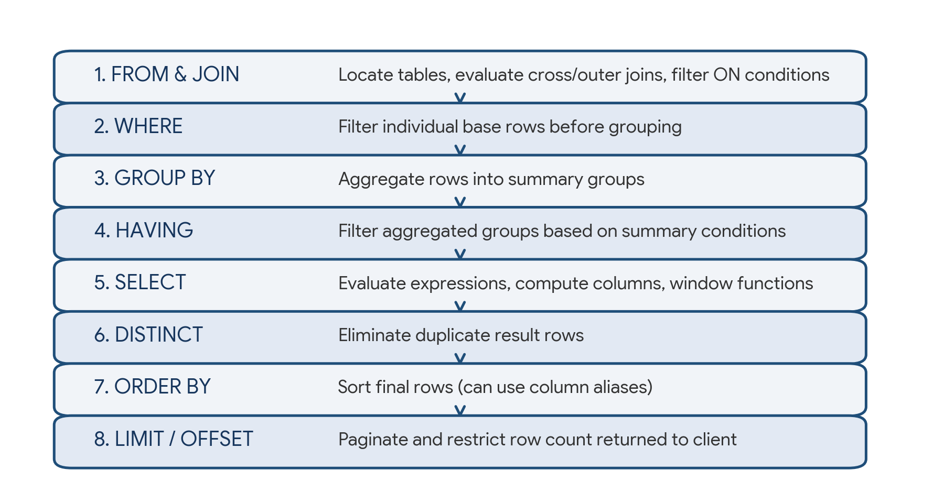
Figure 1. Logical SQL query processing order from initial table identification down to client pagination.
Lexical (Written) Order:
SELECT -> FROM -> JOIN -> WHERE -> GROUP BY -> HAVING -> ORDER BY -> LIMIT

Logical (Execution) Order:
1. FROM & JOIN (Identify tables, evaluate Cartesian products and ON filters)
2. WHERE (Filter base rows before any grouping occurs)
3. GROUP BY (Partition remaining rows into aggregated groups)
4. HAVING (Filter aggregated groups using aggregate expressions)
5. SELECT (Evaluate expressions, assign aliases, compute window functions)
6. DISTINCT (Deduplicate identical rows in the projection)
7. ORDER BY (Sort resulting rows; can use SELECT aliases and column positions)
8. LIMIT / OFFSET (Restrict and paginate the final returned result set)

2. Data Retrieval: SELECT, WHERE, and Filtering Predicates
The SELECT clause specifies the projected columns and expressions. The WHERE clause specifies Boolean search conditions applied to individual rows before any grouping or aggregation takes place.

Core filtering operators and pattern matching
Operator / Predicate | Description | Example Syntax
Comparison (=, !=, <>, <, <=, >, >=) | Standard relational comparison between values | WHERE salary >= 60000 AND dept_id != 5
BETWEEN ... AND ... | Inclusive range test (val >= low AND val <= high) | WHERE hire_date BETWEEN '2025-01-01' AND '2025-12-31'
IN (val1, val2, ...) | Set membership test against explicit values or subquery | WHERE department IN ('CSE', 'AI', 'Data Science')
LIKE / ILIKE | Pattern matching with wildcards (% = multi-char, _ = single-char) | WHERE name LIKE 'A%' (starts with A); ILIKE is case-insensitive
IS NULL / IS NOT NULL | Three-valued logic test for missing or unknown values | WHERE bonus IS NULL (never use col = NULL)
AND, OR, NOT | Logical boolean operators; AND has higher precedence than OR | WHERE (dept = 'IT' OR dept = 'AI') AND status = 'Active'
COALESCE(val1, val2, ...) | Returns the first non-null argument in the sequence | SELECT COALESCE(bonus, 0) AS safe_bonus
CASE WHEN ... THEN ... ELSE END | Conditional branching expression within SELECT or WHERE | CASE WHEN score >= 90 THEN 'A' ELSE 'B' END

Handling Three-Valued Logic (3VL) with NULL
In SQL, comparing any value to NULL using standard comparison operators (=, !=, <, >) yields UNKNOWN rather than TRUE or FALSE. A WHERE clause only keeps rows whose predicate evaluates to TRUE; rows evaluating to FALSE or UNKNOWN are discarded.
-- 1. Standard projection with conditional expressions and COALESCE
SELECT
employee_id,
first_name || ' ' || last_name AS full_name,
department,
salary,
COALESCE(bonus, 0) AS bonus,
salary + COALESCE(bonus, 0) AS total_compensation,
CASE
WHEN salary >= 90000 THEN 'Executive'
WHEN salary >= 60000 THEN 'Senior'
ELSE 'Junior/Mid'
END AS compensation_tier
FROM employees
WHERE status = 'Active'
AND (department IN ('AI', 'CSE') OR experience_years > 5)
AND commission_pct IS NOT NULL;

3. Sorting & Pagination: ORDER BY, LIMIT, and OFFSET
Relational tables are unordered mathematical sets. Without an explicit ORDER BY clause, the database makes zero guarantees about the order in which rows are returned. ORDER BY sorts output by one or multiple expressions in ascending (ASC, default) or descending (DESC) sequence.
Clause / Option | Purpose | Example
ORDER BY col ASC | Sort in ascending order (smallest/earliest first) | ORDER BY hire_date ASC
ORDER BY col DESC | Sort in descending order (largest/latest first) | ORDER BY salary DESC
Multiple columns | Primary sort followed by tie-breaking sort criteria | ORDER BY department ASC, salary DESC
NULLS FIRST / LAST | Explicitly control where null values appear in sort order | ORDER BY bonus DESC NULLS LAST
LIMIT n / FETCH FIRST n ROWS | Restrict returned rows to top n records | LIMIT 10 (or FETCH FIRST 10 ROWS ONLY)
OFFSET m | Skip the first m records before returning rows (pagination) | LIMIT 10 OFFSET 20 (returns page 3)

Pagination query example
-- Retrieve page 2 of employees (10 records per page), highest salary first
SELECT
employee_id,
name,
department,
salary
FROM employees
ORDER BY salary DESC, employee_id ASC -- Deterministic tie-breaker
LIMIT 10 OFFSET 10;

4. Aggregations & Grouping: GROUP BY, HAVING, and Rollups
Aggregate functions take a collection of row values and return a single summarizing scalar value. When combined with GROUP BY, the table is partitioned into buckets, and the aggregation function computes independently across each bucket.
Aggregate Function | Description | NULL Handling Behavior
COUNT(*) | Counts total number of rows in the table or group | Includes NULL rows
COUNT(col) | Counts non-null values in the specified column | Ignores NULLs
COUNT(DISTINCT col) | Counts distinct non-null values in the column | Ignores NULLs
SUM(col) | Computes arithmetic sum of numeric values | Ignores NULLs; returns NULL if group is empty
AVG(col) | Computes arithmetic mean: SUM(col) / COUNT(col) | Ignores NULLs; does not count nulls in denominator
MIN(col) / MAX(col) | Finds minimum or maximum value (numbers, text, dates) | Ignores NULLs
STRING_AGG / GROUP_CONCAT | Concatenates string values within a group with a delimiter | Ignores NULLs

WHERE vs HAVING: The Critical Distinction
Property | WHERE Clause | HAVING Clause
Execution timing | Evaluated BEFORE GROUP BY (filters raw rows) | Evaluated AFTER GROUP BY (filters aggregated groups)
Aggregate functions? | Illegal (e.g., WHERE AVG(salary) > 50000 fails) | Allowed and expected (e.g., HAVING AVG(salary) > 50000)
Scope of filter | Applies to individual records | Applies to group summary values
Index utilization | Can readily utilize B-tree table indexes | Cannot use table indexes directly on aggregate results

Aggregating department performance with HAVING
SELECT
department,
COUNT(*) AS total_employees,
COUNT(bonus) AS employees_with_bonus,
ROUND(AVG(salary), 2) AS avg_salary,
MIN(salary) AS min_salary,
MAX(salary) AS max_salary,
SUM(salary + COALESCE(bonus, 0)) AS total_department_payroll
FROM employees
WHERE status = 'Active' -- Row filter before grouping
GROUP BY department
HAVING COUNT(*) >= 5 -- Group filter after aggregation
AND AVG(salary) > 60000
ORDER BY avg_salary DESC;

5. Relational Joins: Combining Data Across Tables
Joins combine columns from two or more tables based on a logical relationship between them (typically primary key to foreign key matches).
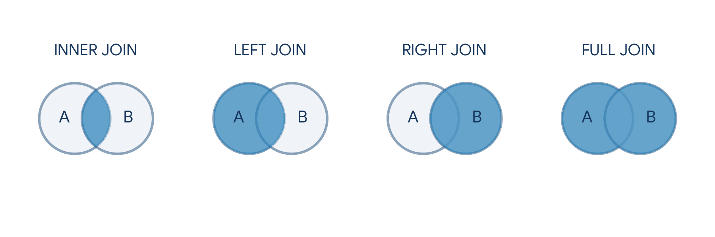
Figure 2. Venn diagrams illustrating result sets for INNER, LEFT, RIGHT, and FULL outer joins.
Join Type | Matching Behavior | Unmatched Row Handling
INNER JOIN | Returns rows where the join condition evaluates to TRUE in both tables | Unmatched rows from both tables are discarded
LEFT (OUTER) JOIN | Returns all rows from Left table, plus matched rows from Right table | Unmatched Right attributes are populated with NULL
RIGHT (OUTER) JOIN | Returns all rows from Right table, plus matched rows from Left table | Unmatched Left attributes are populated with NULL
FULL (OUTER) JOIN | Returns all rows when there is a match in either Left or Right table | Missing values on either side are filled with NULL
CROSS JOIN | Computes Cartesian product (m × n rows) | No ON condition; combines every row with every row
SELF JOIN | A table joined to itself using different table aliases | Useful for hierarchical trees (Employee -> Manager)

Multi-table join and hierarchical self-join examples
-- 1. Multi-table join with LEFT JOIN to preserve projects with no assignments
SELECT
e.employee_id,
e.name AS employee_name,
d.department_name,
p.project_name,
COALESCE(ep.hours_logged, 0) AS hours_logged
FROM employees e
INNER JOIN departments d ON e.department_id = d.department_id
LEFT JOIN employee_projects ep ON e.employee_id = ep.employee_id
LEFT JOIN projects p ON ep.project_id = p.project_id
WHERE d.location = 'San Francisco'
ORDER BY d.department_name, e.name;

-- 2. Hierarchical Self-Join (Employee and their Manager)
SELECT
e.name AS employee_name,
e.job_title,
COALESCE(m.name, 'Top Executive / CEO') AS manager_name
FROM employees e
LEFT JOIN employees m ON e.manager_id = m.employee_id;

6. Subqueries & Common Table Expressions (CTEs)
A subquery is a nested query enclosed in parentheses located within an outer SQL statement. A Common Table Expression (CTE) defines a named temporary result set using the WITH keyword, dramatically improving readability over deeply nested subqueries.
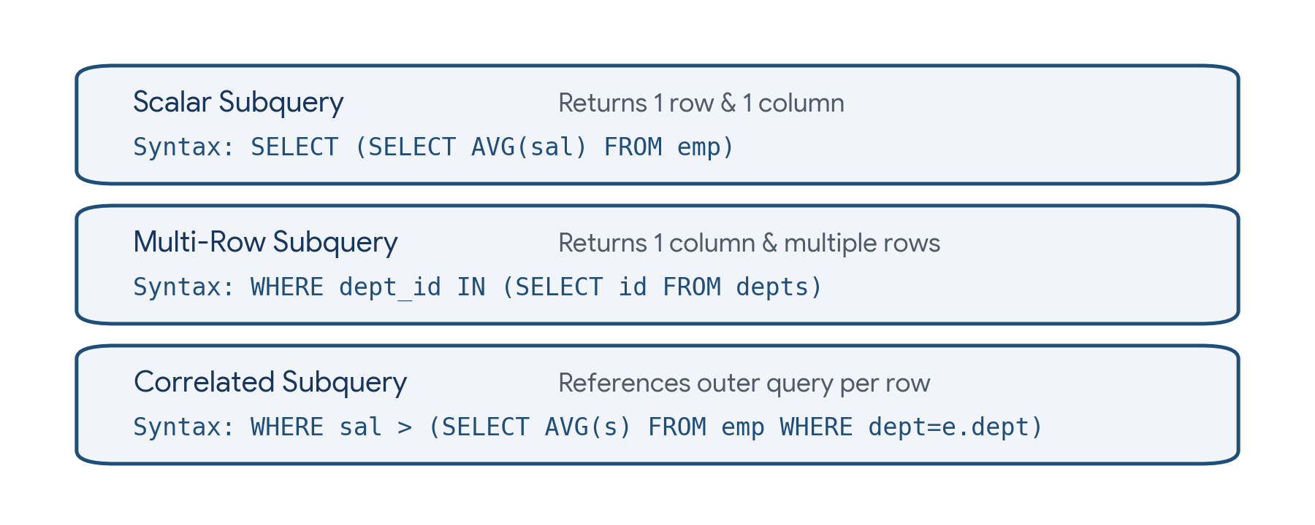
Figure 4. Taxonomy of subquery types: Scalar, Multi-row, and Correlated subqueries.
Subquery Category | Output Dimension | Typical Usage & Operators
Scalar Subquery | Exactly 1 row and 1 column | Used anywhere an expression is valid: SELECT, WHERE (col = (...))
Multi-Row Subquery | 1 column and multiple rows | Used with set operators: IN, NOT IN, ANY/SOME, ALL
Correlated Subquery | Evaluated once for each outer candidate row | References outer table columns; used with EXISTS, NOT EXISTS
CTE (Common Table Expression) | Named tabular result set (WITH cte AS ...) | Breaks complex logic into sequential readable building blocks
Recursive CTE | Iterative self-referencing CTE | Traverses trees, organizational hierarchies, and graph networks

Correlated subquery vs CTE
-- 1. Correlated Subquery: Find employees earning more than their department's average
SELECT
e.employee_id,
e.name,
e.department_id,
e.salary
FROM employees e
WHERE e.salary > (
SELECT AVG(sub.salary)
FROM employees sub
WHERE sub.department_id = e.department_id -- Correlated reference
);

-- 2. Clean CTE Formulation with Department Comparison
WITH DeptStats AS (
SELECT
department_id,
ROUND(AVG(salary), 2) AS dept_avg_salary,
COUNT(*) AS head_count
FROM employees
GROUP BY department_id
)
SELECT
e.employee_id,
e.name,
e.salary,
d.dept_avg_salary,
e.salary - d.dept_avg_salary AS diff_from_avg
FROM employees e
INNER JOIN DeptStats d ON e.department_id = d.department_id
WHERE e.salary > d.dept_avg_salary
ORDER BY diff_from_avg DESC;

7. Analytical Queries & Window Functions
Window functions perform calculations across a set of table rows that are related to the current row, without collapsing the individual rows into a single summary output. While GROUP BY aggregates and compresses rows, window functions retain individual row identities while appending analytical calculations.
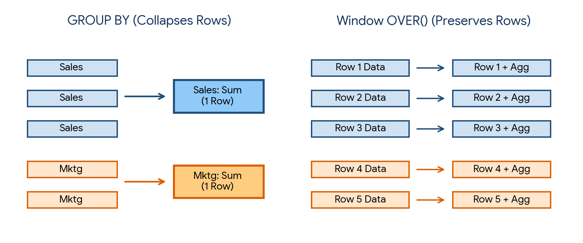
Figure 3. Row preservation: GROUP BY collapses multiple rows, while Window OVER() retains every individual row.
Window Function Family | Functions | Typical Business Use Case
Ranking | ROW_NUMBER(), RANK(), DENSE_RANK() | Identify top-N earners per department, eliminate duplicate rows
Value / Offsets | LAG(col, offset), LEAD(col, offset) | Calculate period-over-period growth, days since last order
Extremes | FIRST_VALUE(col), LAST_VALUE(col) | Compare each transaction against first or baseline transaction
Cumulative Aggregates | SUM(col) OVER(), AVG(col) OVER() | Running totals, rolling 7-day or 30-day moving averages
Distribution | NTILE(n), CUME_DIST(), PERCENT_RANK() | Divide customers into deciles/quartiles, calculate percentile rank

ROW_NUMBER() vs RANK() vs DENSE_RANK()
Rank Function | Handling of Ties (Identical Values) | Output for Values [100, 100, 80]
ROW_NUMBER() | Assigns strictly unique sequential integers; arbitrary tie-breaker | 1, 2, 3
RANK() | Assigns same rank to ties; skips subsequent numbers | 1, 1, 3 (skips rank 2)
DENSE_RANK() | Assigns same rank to ties; never skips numbers | 1, 1, 2 (no gaps in numbering)

Top-N ranking and running total example
-- Find the top 2 highest-paid employees in each department using DENSE_RANK()
WITH RankedEmployees AS (
SELECT
employee_id,
name,
department_id,
salary,
DENSE_RANK() OVER(
PARTITION BY department_id
ORDER BY salary DESC
) AS salary_rank,
SUM(salary) OVER(
PARTITION BY department_id
ORDER BY hire_date
ROWS BETWEEN UNBOUNDED PRECEDING AND CURRENT ROW
) AS running_payroll_total,
LAG(salary, 1) OVER(
PARTITION BY department_id
ORDER BY salary ASC
) AS previous_lower_salary
FROM employees
)
SELECT
employee_id,
name,
department_id,
salary,
salary_rank,
running_payroll_total
FROM RankedEmployees
WHERE salary_rank <= 2
ORDER BY department_id, salary_rank;

8. Database Views & Materialized Views
A View is a stored SQL query definition that acts as a virtual table. Views contain no stored data of their own; whenever a query references a standard view, the database engine executes the underlying query definition. Materialized Views, in contrast, physically persist query results to disk for high-performance reporting on large datasets.
Feature / Aspect | Standard View (CREATE VIEW) | Materialized View (CREATE MATERIALIZED VIEW)
Physical storage | Zero disk storage (only SQL definition stored) | Full disk storage of computed tabular results
Query performance | Recomputed on every single access | Extremely fast; reads precomputed rows directly from disk
Data freshness | Always 100% live and real-time | Stale until explicitly refreshed (REFRESH MATERIALIZED VIEW)
Indexing capability | Cannot be directly indexed (in most RDBMS) | Can be indexed with B-tree, Hash, or GiST indexes
Primary use case | Security access abstraction, business logic encapsulation | Complex analytical aggregations, dashboards, reporting warehouses

Creating views and materialized reporting summaries
-- 1. Standard View: Hide sensitive compensation data from general reporting
CREATE OR REPLACE VIEW v_employee_directory AS
SELECT
employee_id,
name,
department_id,
job_title,
email,
hire_date
FROM employees
WHERE status = 'Active';

-- 2. Materialized View: Precompute heavy cross-department payroll metrics
CREATE MATERIALIZED VIEW mv_department_payroll_summary AS
SELECT
d.department_id,
d.department_name,
COUNT(e.employee_id) AS active_headcount,
ROUND(AVG(e.salary), 2) AS avg_base_salary,
SUM(e.salary + COALESCE(e.bonus, 0)) AS total_payroll_expenditure
FROM departments d
LEFT JOIN employees e ON d.department_id = e.department_id AND e.status = 'Active'
GROUP BY d.department_id, d.department_name;

-- Create an index on the materialized view for fast lookups
CREATE UNIQUE INDEX idx_mv_dept_id ON mv_department_payroll_summary(department_id);

-- Refresh the materialized view periodically
REFRESH MATERIALIZED VIEW CONCURRENTLY mv_department_payroll_summary;

9. Data Modification: Safe UPDATE, DELETE, and Transactions
Data Manipulation Language (DML) commands modify data stored in tables. Because UPDATE and DELETE operate set-wide across all rows unless constrained by a WHERE clause, omitting WHERE results in the accidental overwriting or deletion of entire tables.
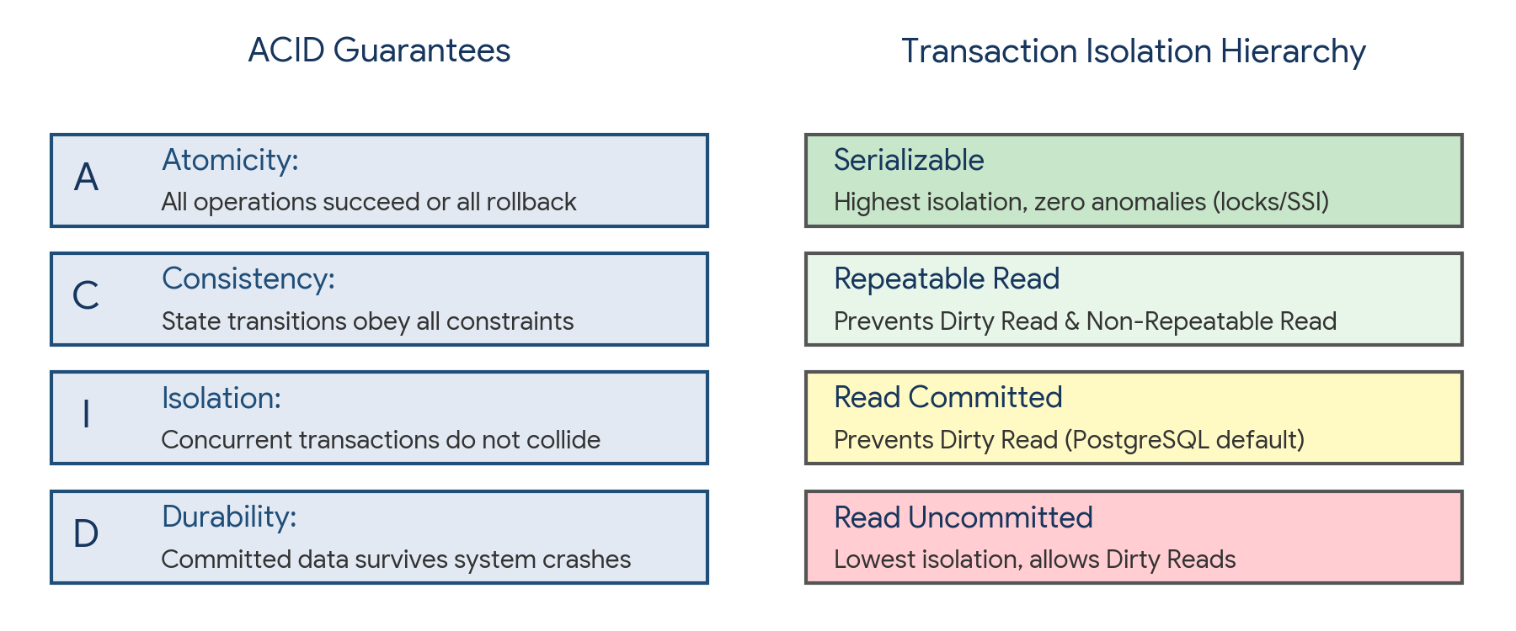
Figure 5. Overview of ACID transaction guarantees and the SQL transaction isolation level hierarchy.
DML / TCL Command | Syntax Pattern | Safety Rule & Guardrail
UPDATE | UPDATE tbl SET col = val WHERE cond; | Always test condition with SELECT * WHERE cond before executing UPDATE
DELETE | DELETE FROM tbl WHERE cond; | Omitting WHERE deletes all rows; prefer soft deletes (is_deleted = TRUE)
TRUNCATE | TRUNCATE TABLE tbl; | DDL operation; instantly removes all rows and resets identity; cannot rollback in some DBs
BEGIN / COMMIT | BEGIN TRANSACTION; ... COMMIT; | Persists all atomic statements permanently to disk
ROLLBACK | ROLLBACK; | Undoes all statements executed since the beginning of the transaction or savepoint

Safe DML updates, soft deletes, and atomic transactions
-- 1. Safe Transactional Update with Rollback Guard
BEGIN TRANSACTION;

-- Verify target row count first
-- SELECT COUNT(*) FROM employees WHERE department = 'IT' AND performance_score >= 90;

UPDATE employees
SET salary = salary * 1.10,
last_modified = CURRENT_TIMESTAMP
WHERE department = 'IT'
AND performance_score >= 90;

-- Sanity check: Ensure updated rows match expectations before committing
-- If something looks wrong: ROLLBACK;
COMMIT;

-- 2. Soft Delete Pattern (Industry Standard)
UPDATE employees
SET is_active = FALSE,
deleted_at = CURRENT_TIMESTAMP
WHERE employee_id = 104;

-- 3. Correlated UPDATE (Update department average salary cache)
UPDATE departments d
SET avg_salary_cache = (
SELECT ROUND(AVG(e.salary), 2)
FROM employees e
WHERE e.department_id = d.department_id
);

10. Practical Project — Enterprise Retail Analytics Database
Objective: design and execute a comprehensive SQL analytics project simulating an e-commerce platform. The project defines relational schemas, seeds transactional sales records, and answers mission-critical business questions using aggregations, multi-table joins, subqueries, views, and window functions.

Project structure
sql_retail_analytics/
|
|-- schema.sql (DDL table definitions with constraints)
|-- seed_data.sql (DML sample data insertion)
|-- analytics.sql (Analytical queries, window functions, reports)
|-- views.sql (Standard and materialized reporting views)

Database schema — schema.sql
CREATE TABLE customers (
customer_id SERIAL PRIMARY KEY,
name VARCHAR(100) NOT NULL,
email VARCHAR(100) UNIQUE NOT NULL,
city VARCHAR(50) NOT NULL,
signup_date DATE DEFAULT CURRENT_DATE
);

CREATE TABLE categories (
category_id SERIAL PRIMARY KEY,
category_name VARCHAR(50) NOT NULL
);

CREATE TABLE products (
product_id SERIAL PRIMARY KEY,
product_name VARCHAR(100) NOT NULL,
category_id INT REFERENCES categories(category_id),
unit_price NUMERIC(10, 2) NOT NULL CHECK (unit_price > 0),
stock_quantity INT DEFAULT 0
);

CREATE TABLE orders (
order_id SERIAL PRIMARY KEY,
customer_id INT REFERENCES customers(customer_id),
order_date DATE NOT NULL,
order_status VARCHAR(20) DEFAULT 'Completed'
);

CREATE TABLE order_items (
item_id SERIAL PRIMARY KEY,
order_id INT REFERENCES orders(order_id) ON DELETE CASCADE,
product_id INT REFERENCES products(product_id),
quantity INT NOT NULL CHECK (quantity > 0),
unit_price NUMERIC(10, 2) NOT NULL
);

Sample seed data — seed_data.sql
INSERT INTO customers (customer_id, name, email, city, signup_date) VALUES
(1, 'Aman Sharma', 'aman@example.com', 'Delhi', '2025-01-15'),
(2, 'Rahul Verma', 'rahul@example.com', 'Mumbai', '2025-02-10'),
(3, 'Simran Kaur', 'simran@example.com', 'Chandigarh', '2025-03-05'),
(4, 'Harshit Patel', 'harshit@example.com', 'Ahmedabad', '2025-03-20'),
(5, 'Neha Gupta', 'neha@example.com', 'Bengaluru', '2025-04-12');

INSERT INTO categories (category_id, category_name) VALUES
(1, 'Electronics'), (2, 'Books'), (3, 'Home & Kitchen');

INSERT INTO products (product_id, product_name, category_id, unit_price, stock_quantity) VALUES
(101, 'Wireless Mouse', 1, 1200.00, 50),
(102, 'Mechanical Keyboard', 1, 4500.00, 30),
(103, 'Noise Cancelling Headphones', 1, 8900.00, 20),
(104, 'SQL & Data Systems Book', 2, 850.00, 100),
(105, 'Coffee Maker', 3, 3400.00, 15);

INSERT INTO orders (order_id, customer_id, order_date, order_status) VALUES
(1001, 1, '2026-01-10', 'Completed'),
(1002, 2, '2026-01-15', 'Completed'),
(1003, 1, '2026-02-05', 'Completed'),
(1004, 3, '2026-02-18', 'Completed'),
(1005, 4, '2026-03-01', 'Completed'),
(1006, 2, '2026-03-12', 'Completed');

INSERT INTO order_items (order_id, product_id, quantity, unit_price) VALUES
(1001, 101, 2, 1200.00),
(1001, 104, 1, 850.00),
(1002, 103, 1, 8900.00),
(1003, 102, 1, 4500.00),
(1003, 105, 1, 3400.00),
(1004, 101, 1, 1200.00),
(1005, 102, 2, 4500.00),
(1006, 104, 3, 850.00);

Comprehensive analytics query suite — analytics.sql
-- 1. Customer Lifetime Value (CLV) & Order Frequency
SELECT
c.customer_id,
c.name AS customer_name,
c.city,
COUNT(DISTINCT o.order_id) AS total_orders,
COALESCE(SUM(oi.quantity * oi.unit_price), 0) AS total_spend,
ROUND(COALESCE(AVG(oi.quantity * oi.unit_price), 0), 2) AS avg_item_spend
FROM customers c
LEFT JOIN orders o ON c.customer_id = o.customer_id
LEFT JOIN order_items oi ON o.order_id = oi.order_id
GROUP BY c.customer_id, c.name, c.city
ORDER BY total_spend DESC;

-- 2. Product Revenue Contribution with Window Percentile
WITH ProductRevenue AS (
SELECT
p.product_id,
p.product_name,
cat.category_name,
SUM(oi.quantity * oi.unit_price) AS product_sales
FROM products p
INNER JOIN categories cat ON p.category_id = cat.category_id
INNER JOIN order_items oi ON p.product_id = oi.product_id
GROUP BY p.product_id, p.product_name, cat.category_name
)
SELECT
product_name,
category_name,
product_sales,
ROUND(100.0 * product_sales / SUM(product_sales) OVER(), 2) AS pct_total_revenue,
DENSE_RANK() OVER(PARTITION BY category_name ORDER BY product_sales DESC) AS rank_in_category
FROM ProductRevenue
ORDER BY category_name, rank_in_category;

-- 3. Monthly Month-over-Month (MoM) Revenue Growth Using LAG()
WITH MonthlySales AS (
SELECT
DATE_TRUNC('month', o.order_date) AS sales_month,
SUM(oi.quantity * oi.unit_price) AS monthly_revenue
FROM orders o
JOIN order_items oi ON o.order_id = oi.order_id
GROUP BY DATE_TRUNC('month', o.order_date)
)
SELECT
TO_CHAR(sales_month, 'YYYY-MM') AS month_label,
monthly_revenue,
LAG(monthly_revenue, 1) OVER(ORDER BY sales_month) AS prev_month_revenue,
ROUND(
100.0 * (monthly_revenue - LAG(monthly_revenue, 1) OVER(ORDER BY sales_month))
/ NULLIF(LAG(monthly_revenue, 1) OVER(ORDER BY sales_month), 0),
2
) AS mom_growth_pct
FROM MonthlySales
ORDER BY sales_month;

Project notes: this script illustrates proper relational design with primary and foreign key constraints, graceful NULL handling using COALESCE and NULLIF to prevent division-by-zero errors, and advanced window functions (DENSE_RANK, LAG, SUM OVER) to compute production-ready financial metrics.

11. Common Mistakes & Query Anti-Patterns to Avoid
- Filtering on aggregate results inside WHERE (e.g., WHERE COUNT(*) > 5) instead of using the HAVING clause.
- Referencing a SELECT column alias in the WHERE clause, which violates the logical query processing execution order.
- Using col = NULL or col != NULL instead of the proper three-valued logic predicates IS NULL or IS NOT NULL.
- Writing SELECT * in production application queries instead of projecting explicitly needed columns (causes unnecessary I/O and network overhead).
- Accidental Cartesian products caused by missing or incomplete ON conditions in multi-table JOIN operations.
- Using NOT IN with a subquery that returns a NULL value, which causes the entire NOT IN predicate to evaluate to UNKNOWN and return zero rows.
- Forgetting WHERE in UPDATE or DELETE statements, wiping out or overwriting entire production tables.
- Using UNION instead of UNION ALL when deduplication is unnecessary, forcing expensive sorting and hashing operations.
- Applying non-sargable functions on indexed columns in the WHERE clause (e.g., WHERE YEAR(order_date) = 2026), preventing B-tree index seeks.

12. Quick Revision — Key Differences
Comparison | First Concept | Second Concept
WHERE vs HAVING | Filters base individual rows BEFORE grouping; no aggregates | Filters grouped summary rows AFTER aggregation; uses aggregates
INNER JOIN vs LEFT JOIN | Keeps only matching rows from both tables | Keeps all rows from left table; fills missing right side with NULL
UNION vs UNION ALL | Combines result sets and eliminates duplicate rows (slower) | Combines result sets without deduplication (faster)
DELETE vs TRUNCATE | DML statement; deletes row-by-row; can rollback; fires triggers | DDL statement; deallocates pages; faster; resets identity
RANK() vs DENSE_RANK() | Leaves gaps in numbering after ties (e.g., 1, 1, 3) | Consecutive numbering without gaps (e.g., 1, 1, 2)
View vs Materialized View | Virtual stored query; recomputed on every execution | Physically stored table on disk; requires explicit refresh
Scalar vs Correlated Subquery | Executes once independently; returns 1 single value | Executes once per outer row; references outer table columns

13. Important Syntax & Relational Cheat Sheet
SQL Construct | Canonical Syntax Pattern
Standard Aggregation | SELECT col, COUNT(*), AVG(num) FROM tbl WHERE cond GROUP BY col HAVING COUNT(*) > n;
Conditional Projection | SELECT CASE WHEN score >= 90 THEN 'A' WHEN score >= 75 THEN 'B' ELSE 'C' END AS grade FROM t;
Inner & Left Join | SELECT * FROM t1 [INNER | LEFT] JOIN t2 ON t1.id = t2.fkey WHERE cond;
Common Table Expression | WITH cte_name AS (SELECT col, SUM(x) AS total FROM tbl GROUP BY col) SELECT * FROM cte_name;
Window Function Over Partition | SELECT col, ROW_NUMBER() OVER(PARTITION BY dept_id ORDER BY salary DESC) AS rnk FROM emp;
Cumulative Running Total | SELECT date, amt, SUM(amt) OVER(ORDER BY date ROWS BETWEEN UNBOUNDED PRECEDING AND CURRENT ROW) FROM s;
Safe DML Transaction | BEGIN TRANSACTION; UPDATE tbl SET col = val WHERE cond; COMMIT; (or ROLLBACK;)
Soft Delete Pattern | UPDATE tbl SET is_deleted = TRUE, deleted_at = CURRENT_TIMESTAMP WHERE id = target_id;

14. Interview / Viva Questions
What is the logical query processing order in SQL?
FROM & JOIN -> WHERE -> GROUP BY -> HAVING -> SELECT -> DISTINCT -> ORDER BY -> LIMIT/OFFSET.
Why can't you use a column alias defined in SELECT inside the WHERE clause?
Because WHERE executes at Step 2 before SELECT evaluates expressions and creates column aliases at Step 5.
What is the difference between WHERE and HAVING?
WHERE filters raw individual records before grouping and cannot evaluate aggregates; HAVING filters grouped rows after aggregation and evaluates aggregate expressions.
What is the difference between COUNT(*) and COUNT(column)?
COUNT(*) counts all rows including NULLs; COUNT(column) counts only non-null values in that specific column.
How does SQL evaluate NULL in comparison operations?
SQL uses three-valued logic (TRUE, FALSE, UNKNOWN). Any comparison with NULL (=, !=, <) results in UNKNOWN. Only IS NULL and IS NOT NULL resolve correctly.
What is the difference between INNER JOIN and LEFT JOIN?
INNER JOIN returns rows that have matches in both tables; LEFT JOIN returns all rows from the left table and matches from the right table, replacing missing right values with NULL.
What is the difference between UNION and UNION ALL?
UNION combines queries and eliminates duplicate rows via sorting or hashing; UNION ALL combines all rows including duplicates and is significantly faster.
What is the difference between ROW_NUMBER(), RANK(), and DENSE_RANK()?
ROW_NUMBER assigns strictly sequential integers (1, 2, 3); RANK assigns equal numbers to ties and skips subsequent ranks (1, 1, 3); DENSE_RANK assigns equal numbers to ties without gaps (1, 1, 2).
What is the purpose of the PARTITION BY clause in window functions?
It divides the dataset into independent subsets or windows across which the window function calculates, without collapsing the individual rows.
What do LAG() and LEAD() do?
LAG accesses data from a preceding row at a specified physical offset; LEAD accesses data from a subsequent following row, enabling period-over-period delta calculations.
What is a Common Table Expression (CTE) and when should it be used?
A CTE is a named temporary result set defined using the WITH clause. It simplifies complex nested subqueries, enables reusability within a single query, and supports recursive queries.
What is a correlated subquery?
A subquery that references columns from the outer query. It is evaluated once for every candidate row processed by the outer query.
Why can NOT IN behave unpredictably with NULL values?
If the subquery returns even a single NULL value, the NOT IN expression evaluates to UNKNOWN for all rows, causing the query to return zero results. Use NOT EXISTS instead.
What is the difference between DROP, TRUNCATE, and DELETE?
DELETE is a DML command that removes rows one-by-one and can be rolled back; TRUNCATE is a DDL command that deallocates data pages quickly; DROP removes the entire table structure and schema.
What is the difference between a standard View and a Materialized View?
A standard view is a virtual query definition recomputed on every execution; a materialized view physically stores the computed results on disk and must be explicitly refreshed.
What are ACID properties in database transactions?
Atomicity (all-or-nothing), Consistency (rules/constraints enforced), Isolation (concurrent operations do not interfere), and Durability (committed data survives crashes).
What is a surrogate key vs a natural key?
A natural key is composed of real-world attributes with business meaning (e.g., SSN, email); a surrogate key is an artificial, system-generated identifier (e.g., auto-incrementing integer or UUID).
What is the difference between COALESCE() and IFNULL() / NVL()?
COALESCE is standard ANSI SQL and accepts two or more arguments, returning the first non-null value; IFNULL (MySQL) and NVL (Oracle) accept only two arguments.
What is the difference between clustered and non-clustered indexes?
A clustered index defines the physical order of table storage (only one per table); a non-clustered index creates a separate B-tree structure pointing back to data rows.
What does a sargable query mean?
A query with Search Argument Able predicates that allows the database engine to utilize an index seek rather than scanning the entire table.

15. Coding Practice
- Write a query to retrieve all active employees in department 10 earning between 50,000 and 90,000, sorted by hire date descending.
- Calculate the total headcount, average salary, and maximum bonus for each department, keeping only departments with more than 3 employees.
- Perform an INNER JOIN between customers, orders, and order_items to compute the total invoice amount for order ID 1001.
- Write a LEFT JOIN query to identify all customers who have never placed an order.
- Construct a hierarchical self-join query that lists every employee's name along with their immediate manager's name.
- Write a correlated subquery to find all products whose unit price is strictly higher than the average price of products in their category.
- Rewrite the previous query using a Common Table Expression (CTE) and an INNER JOIN.
- Use DENSE_RANK() to assign salary rankings within each department and filter to return the top 3 highest earners per department.
- Write a query using LAG() to compute the month-over-month percentage change in company sales revenue.
- Create a standard view v_active_customer_orders that abstracts customer information, order status, and total purchase value.
- Write a safe transaction block in SQL that updates inventory quantity and rolls back if stock drops below zero.
- Implement a soft-delete query on an accounts table and verify that deleted records are excluded from reporting views.

16. Day 388 Completion Checklist
- ☐ Master the logical query processing execution order (FROM -> WHERE -> GROUP BY -> HAVING -> SELECT -> ORDER BY).
- ☐ Construct selective filtering predicates using comparison operators, BETWEEN, IN, LIKE, and IS NULL.
- ☐ Sort and paginate result sets deterministically using ORDER BY, LIMIT, and OFFSET.
- ☐ Compute group-level summaries using COUNT, SUM, AVG, MIN, MAX, and filter with HAVING.
- ☐ Combine relational tables using INNER, LEFT, RIGHT, FULL, CROSS, and SELF joins.
- ☐ Construct scalar, multi-row, and correlated subqueries, and compare with CTEs.
- ☐ Write analytical window queries using ROW_NUMBER, RANK, DENSE_RANK, LAG, LEAD, and running totals.
- ☐ Build and manage standard views and materialized reporting summaries.
- ☐ Execute safe DML updates, soft deletes, and atomic ACID transactions.
- ☐ Implement the Enterprise Retail Analytics Database practical project.
- ☐ Complete all 12 coding practice challenges and revise the 20 interview/viva questions.

17. Learning Outcomes
After completing this revision, you should be able to:
- Formulate clean, efficient, and syntactically correct SQL queries for data extraction and reporting.
- Explain and debug execution behavior based on logical query processing order.
- Accurately aggregate and filter complex multidimensional business metrics.
- Choose the appropriate join strategy to combine normalized relational schemas without data loss.
- Decompose complex analytical questions into modular, readable Common Table Expressions.
- Apply window functions to solve advanced ranking, pagination, and time-series trend analysis.
- Design database views and execute safe, recoverable transactional modifications in production.
Next recommended topic: Day 389 — Advanced SQL & Database Performance: Query Optimization, EXPLAIN ANALYZE, B-Tree & Hash Indexing, Partitioning, and Query Profiling.

